**R.M.D. ENGINEERING COLLEGE**

**(An Autonomous Institution)**



**R.S.M Nagar, Kavaraipettai, Gummidipoondi Taluk, Thiruvallur District, Tamil Nadu- 601206**

Affiliated to Anna University, Chennai / Approved by AICTE, New Delhi/Accredited by NAAC An ISO 9001:2015 Certified Institution / All the Eligible UG Programs are accredited by NBA, New Delhi

**DEPARTMENT OF INFORMATION TECHNOLOGY**

**21IT413**

**INTERNSHIP**

**MOBILE SHOP REPAIR CENTER**

**GOKUL.V -111521203015**

**INIYA VISHAL - 111521203019**

**KISHORE.R - 111521203029**

1

**21IT401 SOFTWARE ENGINEERING LABORATORY**

**OBJECTIVES:**

* To understand the software engineering methodologies for project development.



* To gain knowledge about open source tools for Computer Aided Software Engineering.
* To develop an efficient software using case tools.

**SOFTWARE REQUIRED:**

Open source Tools: Star UML / UML Graph / Top cased

Prepare the following documents for each experiment and develop the software using software engineering methodology.

1. **Problem Analysis and Project Planning -**Thorough study of the problem – Identify Project scope, Objectives and Infrastructure.
2. **Software Requirement Analysis -** Describe the individual Phases/modules of the project and Identify deliverables.
3. **Data Modelling -** Use work products – data dictionary, use case diagrams and activity diagrams, build and test class diagrams, sequence diagrams and add interface to class diagrams.
4. **Software Development and Debugging** – implement the design by coding
5. **Software Testing** - Prepare test plan, perform validation testing, coverage analysis, memory leaks, develop test case hierarchy, Site check and site monitor.

**INDEX**

|  |  |
| --- | --- |
| **SL.NO** | **NAME OF THE EXPERIMENT** |
|  | **MOBILE SHOP REPAIR CENTER** |
| 1 | Problem Analysis    1(a)Problem Statement |
|  | 1(b)Project Planning |
| 2 | Software Requirement Analysis |
| 3 | Modelling  3(a)Design  3(b)Data Dictionary |
| 4 | Implementation |
| 5 | Testing - Test Cases |
| 6 | Documentation |

**Ex. No 1(a) PROBLEM ANALYSIS**

**Problem Statement**

Mobile Shop Repair Center

1) Raise a Customer Request for Service

2) Generate next token number

3) Update the Service Completion with Cost Involved

4) Report of Serviced Phone within a Given date range

**Analysis**

System analysis is a process of gathering and interpreting facts, diagnosing problems and the information about the Point Of Sale System to recommend improvements on the system. It is a problem solving activity that requires intensive communication between the system users and system consumers. System Analysis or study is an important phase of any system development process. The system is studied to the minutest detailed and analyzed.

The Outputs from the organizations are traced to the various processes. System analysis is concerned with becoming aware of the problem, identifying the relevant and decisional variables, analyzing and synthesizing the various factors and determining an optimal or at least a satisfactory solutio0n or program of action.

A detailed study of the processes must be made by various techniques like interviews questionaries, etc., The data is allocated by these sources must be scrutinized to arrive to a a conclusion. The conclusion is an understanding of how the system functions .This system is called the existing System .Now the existing system is subjected to close study and problem areas are identified .The designer now functions as a problem server and tries to get a sort out.

**Feasibility study**

**Technical feasibility**

Themobile shop repair center runs with a minimum system resources:

* CSHARK

Above said system resources are available as open source. Hence it is feasible to develop mobile shop

Repair center in this environment.

**Operational feasibility**

As the system has based on GUI no special skill set is required for working with the system, hence it is operationally feasible.

**Economic feasibility**

As the Mobile shop repair center requires minimum system resources, hence it is economically feasible.

**Ex.No 1(b) PROJECT PLANNING**

* 1. **Overview**

A mobile shop repair center is a place where a customer wants to repair their mobile they request the mobile repair center.

A mobile repair center has to generate a token the token number is considered to repair their mobiles. After the token is generated then update the service completion with cost involved.

Mobile shop repair center has to report the serviced phone with in a given date range..

* 1. **Goals and Scope**

**Goal :** To automate the mobile shop repair center with the following functional goals

1) Raise a Customer Request for Service

2) Generate next token number

3) Update the Service Completion with Cost Involved

4) Report of Serviced Phone within a given date range

**Scope :** Considering India has a large population spread among cities, cities, and rural areas. the mobile phone industry is expanding rapidly both domestically and internationally. The huge competition in the company has resulted in a product both technologically sophisticated and at a reasonable price. Different areas where we can use these applications are:

1. Everyone using mobile these day so scope automatically appears.
2. As I said in beginning you have to be expert for any type of mobile services Software as well hardware.
3. Start along with a mobile accessories or mobile selling shop.
4. Once you client base and popularity grown just look for finanace. And look for supporting hands and open another shop in any crowded area.
5. Once you have 2 or 3 service outlet and good funding in hand try to contact for mobile companies to look for service centres. Ensure that you have all the legalized brand name and documents which may be primary requirements to applying.

**1. Schedule and Budget**

**Work Breakdown Structure**

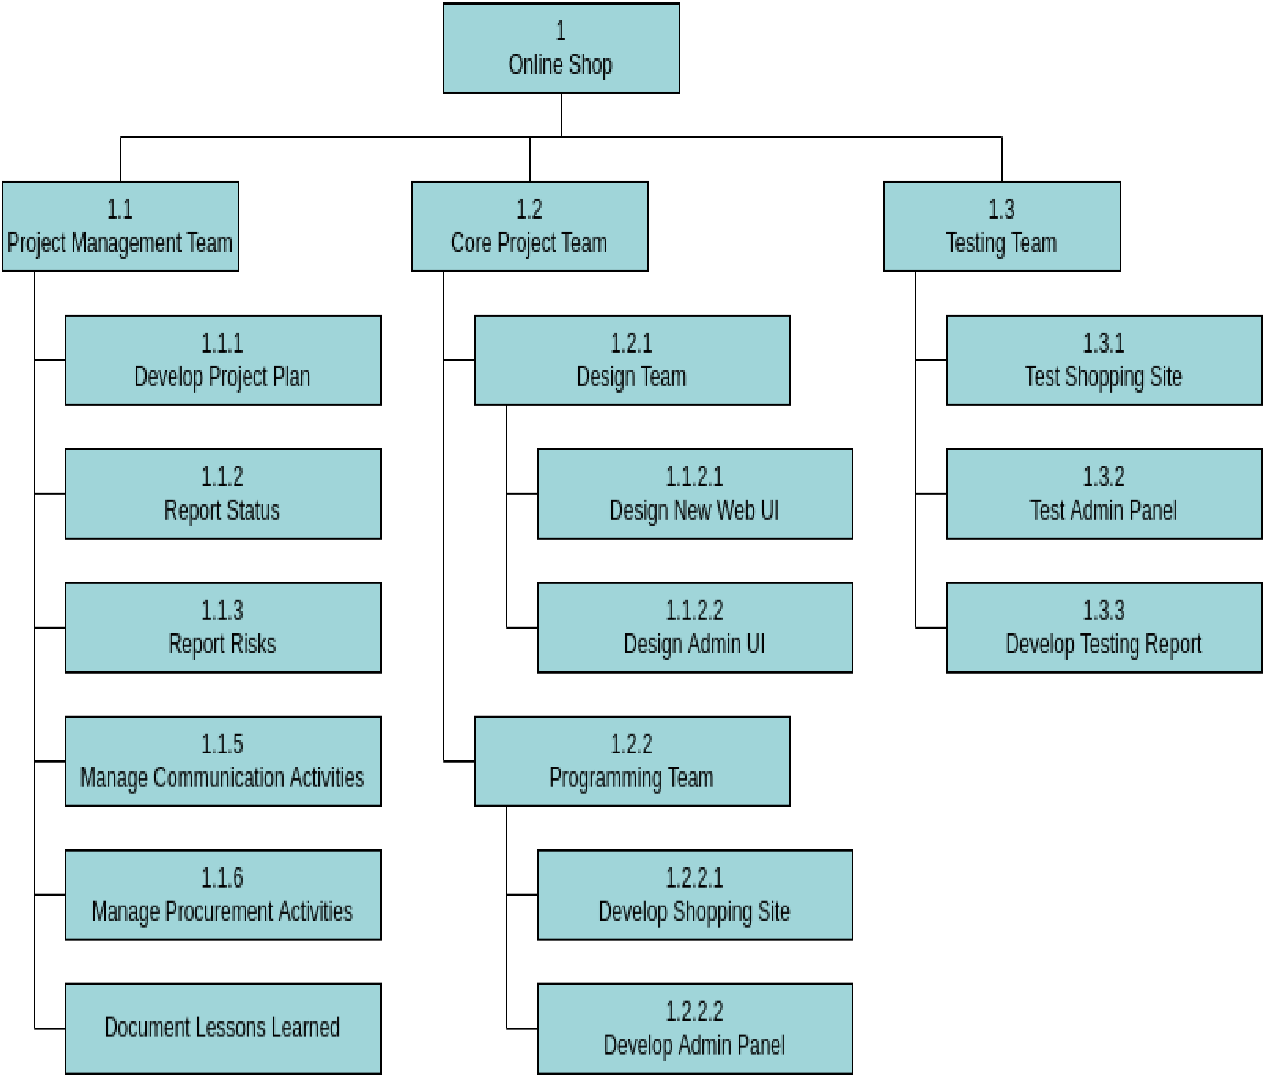

**Schedule and Milestones**

|  |  |  |  |
| --- | --- | --- | --- |
| **Milestones** | **Description** | **Milestone Criteria** | **Planned week** |
| M0 | Problem Analysis |  | 1st week |
|  |  | Problem statement,  Analysis, Feasibility Study |  |
| M1 | Project Planning |  | 2nd week |
|  |  | Scope and concept described |  |
| M2 | Requirement Analysis |  | 2nd and 3rd week |
|  |  | Draft SRS, Design  Specification, Test Plan,  Requirement Analysis  (Final) |  |
| M3 | Study of UML Notations |  | 3rd week |
|  |  | Architecture reviewed and stable |  |
| M4 | Modelling |  | 4th week |
|  |  | Software Design, Data Dictionary |  |

**Budget**

|  |  |  |  |  |  |  |
| --- | --- | --- | --- | --- | --- | --- |
| **Category** |  | **Budget for Period in kUS$** | | | |  |
|  | **M0-M1** | **M1-M2** | **M2-M3** | **M3-M4** | **M4-M5** | **M5-M6** |
| Human Resources (internal) |  |  |  |  |  |  |
| Human Resources (external) |  |  |  |  |  |  |
| Purchases (COTS) |  |  |  |  |  |  |
| Equipment |  |  |  |  |  |  |
| Premises |  |  |  |  |  |  |
| Tools |  |  |  |  |  |  |
| Travel costs |  |  |  |  |  |  |
| Training |  |  |  |  |  |  |
| Review activities |  |  |  |  |  |  |
| Other |  |  |  |  |  |  |
| Total | 1 | 1 | 2 | 5 | 2 | 1 |
| **Total cumulated** | **1** | **2** | **4** | **9** | **11** | **12** |

For a detailed list of costs of all resources see <document> [x].

**Development**

**Process**

**Problem**

**Analysis**

**Create**

**Data**

**Dictionary**

**Problem**

**Planning**

**Require**

**-**

**ment**

**Analysis**

**Model**

**-**

**ling**

**Coding**

**UML**

**design**

**Testing**

**Risk Management**

Unexpected Holidays, Non availability of computer resources, Absence of Human Resource are the identified risks for not meeting the deadlines. Additional efforts need to put in by the human resources to complete the work within the deadline by the way of working after working hours.

**Delivery Plan**

|  |  |  |  |
| --- | --- | --- | --- |
| **Ident.** | **Deliverable** | **Planned Date** | **Receiver** |
| D1 | Analysis and Feasibility Report | 1st week | Client |
| D2 | Project Plan | 2nd week | Client |
| D3 | SRS | 3rd week | Client |
| D4 | Design | 4th week | Client |
| D5 | Test Plan | 5th week | Client |
| D6 | Code | 6th week | Client |
| D7 | Test Report | 6th week | Client |

**Ex.No.2 SOFTWARE REQUIREMENT ANALYSIS**

**Software Requirement Specification (SRS)**

**1. Introduction**

Mobile phone repair technicians run tests to assess the mobile phones' functionality, install and update phone software, troubleshoot wiring problems, and replace damaged parts and components such as batteries, LCD screens, keypads, buttons.

**Purpose of the requirements document**

They are the immediate go-to place for people whose phone suddenly crashes down or when it's not functioning well. If you need the screen protector, glass replacement or other types of spare parts, these repair shops are the best place to find spare parts for your mobile phone.

**Scope of the product**

The Software Requirements Specification captures all the requirements in a single document. The mobile shop repair center will be designed in the way that is going to provide a computerized management and control over business taking place within a shop located in certain locations.

**Definitions, acronyms and abbreviations**

SRS-Software Requirement Specification

OUCD-Overall Use Case Diagram

MSRC – mobile shop repair center

UCS-Use Case Specification

XML - extensible markup language

**References**

(i) ANSI/IEEE std 830-1998, IEEE Recommended Practice for Software Requirements Specifications. (ii) ANSI/IEEE std 1233-1996, IEEE Guide for Developing System Requirements Specification. (iii)<http://www.softwareengineering-9.com/>

**1.5. Overview of the remainder of the document**

The SRS will provide a detailed description of the Mobile shop repair center. This document will provide the outline of the requirements, overview of the characteristics and constraints of the system.

Section 2 of this document provides the General description such as generate tokens, Update the Service Completion with Cost Involved. Section 3 describes the Specific requirements which cover the functional, non-functional and interface requirements. This is obviously the most substantial part of the document but because of the wide variability in organizational practice, it is not appropriate to define a standard structure for this section. The requirements may document external interfaces, describe system functionality and performance, specify logical database requirements, design constraints, emergent system properties and quality characteristics.

**2. General description**

**Product perspective**

Mobile shop repair center will have two main parts which are:

1) Token Sytem which will generate token for customers those who are requesting for service and Service system which will allow the admin to service damaged mobiles based on the generated token number.

2)End Users are customers who are willing to service their mobile.

**Product functions**

The Functional Requirements are those business functions which will be included in this software under development. Functional requirements describe the features of the product and what the system must do so as to fulfil the intended user requirements.

The following are functional requirements which will be provided by the Mobile shop repair center:

1. Mobile shop repair center will enable users to request to service their mobile.
2. Mobile shop repair center will generate token for service in the order of their request.
3. Mobile shop repair center will allow the admin (Employee) to service mobile based on the token number.

**User characteristics**

**Administrator:**

The Administrator is one of the two users of the system. In this case the Administrator is the Employee of the mobile shop .However there can be more than one Administrator.

Administrators can access the view request module and the report module. The administrators of the system to have more knowledge of the internals of the system and is able to rectify the small problems that may arise due to disk crashes, power failures and other catastrophes to maintain the system.

**Customers:**

The customers are the second users of the Mobile shop repair center. They can send request and view their token and even they can view their status and their final report.

**General constraints**

* The service should be made according to the generated token.

.

* MSRC is connected to the server computer and is running all 24 hours a day.

**Assumptions and dependencies**

* The users have sufficient knowledge of computers.
* The users know the English language, as the user interface will be provided in English
* The users know the basic details about their mobile.

**3. Specific requirements**

**Functional Requirements**

**Functionality:**

Selection between cash and management system area:

The token is generated using an automated system. So there is no third person’s influence.

**Management System:**

Admin Management, customer Management, Token Management, Service Management.

.

**Non- Functional Requirements**

**Usability**

The system is user friendly and self-explanatory.

**Reliability**

The system has to be very reliable due to the importance of data and the damages incorrect or incomplete data can do.

**Availability**

The system is available 100% for the user and is used 24 hours a day and 365 days a year. The system shall be operational 24 hours a day and 7 days a week.

**Mean Time Between Failures (MTBF)**

The system will be developed in such a way that it ***may*** fail once in a year.

**Mean Time to Repair (MTTR)**

Even if the system fails, the system will be recovered back up within an hour or less.

**Accuracy**

The accuracy of the system is limited by the accuracy of the speed at which the employees of the and users of the use the system.

**Maximum Bugs or Defect Rate**

Not specified.

**Access Reliability**

The system shall provide 100% access reliability.

**Performance**

**Response Time**

The system shall respond to the member in not less than two seconds from the time of the request submittal. The system shall be allowed to take more time when doing large processing jobs.

The requirements may document external interfaces, describe system functionality and performance, specify logical database requirements, design constraints, emergent system properties and quality characteristics.

**Hardware and software requirements**

Hardware Interfaces

Processor: Anyone

RAM: 2GB or Higher

1. 3..2. Software Interfaces



* Visual Studio
* Base: Local Root.

**3.4 External Interfaces**

**User Interfaces**

The user-interface of the system shall be designed as shown in the user-interface prototypes.

1. **Appendices**

1. **Index**

**Result:** Thus the Software Requirement Specification Document for Mobile shop repair center System has been completed.

**Ex. No. 3 MODELING**

**(i) Design model –UML diagrams**

**Use case diagram**

**Step 1:start LUCID CHART->Create-> Use Case Diagram**

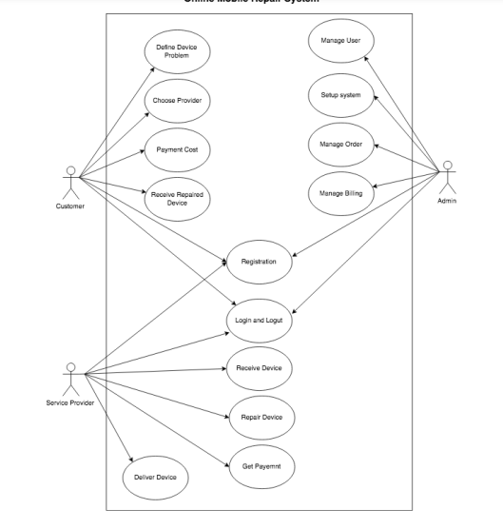

**Activity Diagram for Mobile MSRC**

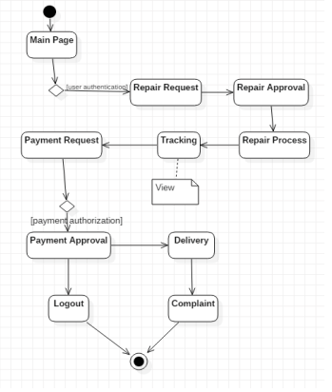

**Sequence diagram for** Mobile shop repair center

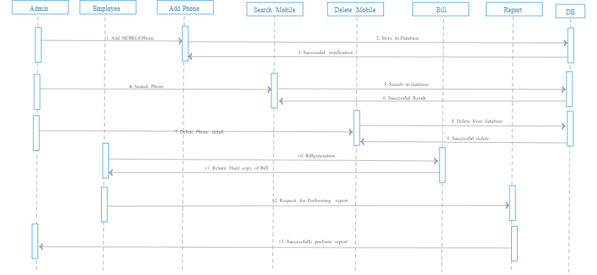

**Class Diagram**

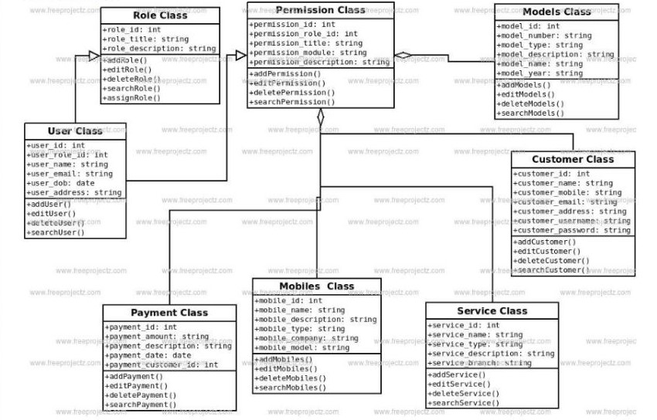

**Ex.No.3 (b) DATADICTIONARY**

**Details**

|  |  |  |  |  |  |
| --- | --- | --- | --- | --- | --- |
| **S.No** | **Name** | **Alias Name** | **How Used** | **Supplementary Data** | |
| **Data Type** | **Limitations** |
| 1 | Customer  name | Price | Buy | string | Up to 20 char |
| 2 | Product  Name | Price | Pay | integer | Up to 16 digit |

**User Details**

|  |  |  |  |  |  |
| --- | --- | --- | --- | --- | --- |
| **S.No** | **Name** | **Alias Name** | **How Used** | **Supplementary Data** | |
| **Data Type** | **Limitations** |
| 1 | User name | Name | For Printing Purpose | string | Up to 20 char |
| 2 | Phone Number | Number | For Printing Purpose | string | Up to 10 char |

**Ex.No.4 IMPLEMENTATION**

App.config

<?xml version="1.0" encoding="utf-8" ?>

<configuration>

<startup>

<supportedRuntime version="v4.0" sku=".NETFramework,Version=v4.7.2" />

</startup>

</configuration>

Login.cs

using System;

using System.Collections.Generic;

using System.ComponentModel;

using System.Data;

using System.Drawing;

using System.Linq;

using System.Text;

using System.Threading.Tasks;

using System.Windows.Forms;

namespace bal

{

public partial class Login : Form

{

public Login()

{

InitializeComponent();

}

private void pictureBox3_Click(object sender, EventArgs e)

{

Application.Exit();

}

private void LoginBtn_Click(object sender, EventArgs e)

{

if(UNameTb.Text==""|| PasswordTb.Text=="")

{

MessageBox.Show("Missing Data!!!");

}

else if(UNameTb.Text=="Admin"&& PasswordTb.Text=="Admin")

{

Repairs Obj = new Repairs();

Obj.Show();

this.Hide();

}

else

{

MessageBox.Show("Wrong UserName Or Password!!!");

}

}

}

}

Functions.cs

using Microsoft.SqlServer.Server;

using System;

using System.Collections.Generic;

using System.Data;

using System.Data.SqlClient;

using System.Linq;

using System.Text;

using System.Threading.Tasks;

namespace bal

{

class Functions

{

private SqlConnection Con;

private SqlCommand Cmd;

private DataTable dt;

private SqlDataAdapter sda;

private string ConStr;

public Functions()

{

ConStr = "Data Source=(LocalDB)\\MSSQLLocalDB;AttachDbFilename=\"C:\\Users\\Iniya Vishal\\Documents\\MobileRepairDb.mdf\";Integrated Security=True;Connect Timeout=30";

Con = new SqlConnection(ConStr);

Cmd = new SqlCommand();

Cmd.Connection = Con;

}

public DataTable GetData(string Query)

{

dt=new DataTable();

sda = new SqlDataAdapter(Query,ConStr);

sda.Fill(dt);

return dt;

}

public int setData(string Query)

{

int Cnt = 0;

if(Con.State== ConnectionState.Closed)

{

Con.Open();

}

Cmd.CommandText = Query;

Cnt = Cmd.ExecuteNonQuery();

return Cnt;

}

}

}

Packages.config

<?xml version="1.0" encoding="utf-8"?>

<packages>

<package id="Guna.UI2.WinForms" version="2.0.4.4" targetFramework="net472" />

</packages>

Program.cs

using System;

using System.Collections.Generic;

using System.Linq;

using System.Threading.Tasks;

using System.Windows.Forms;

namespace bal

{

internal static class Program

{

/// <summary>

/// The main entry point for the application.

/// </summary>

[STAThread]

static void Main()

{

Application.EnableVisualStyles();

Application.SetCompatibleTextRenderingDefault(false);

Application.Run(new Login());

}

}

}

**OUTPUT:**

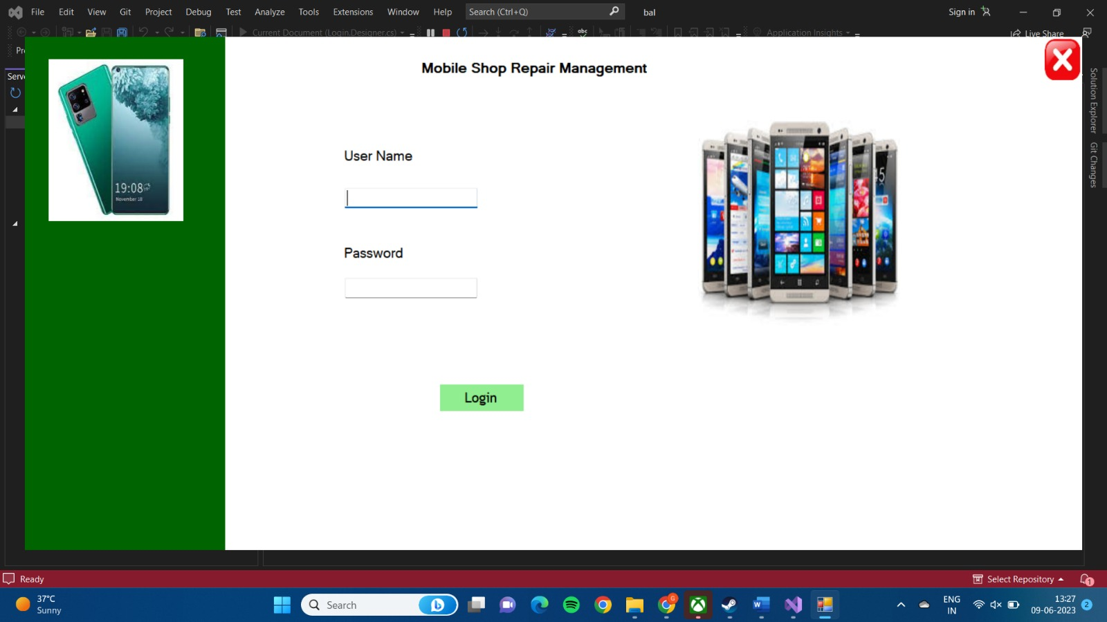

**Ex.No 5 TESTING**

**Test cases:**

|  |  |  |  |  |  |
| --- | --- | --- | --- | --- | --- |
| **Name** | **Requirement** | **Description** | **Input** | **Expecte d O/P** | **Actual O/P** |
| Pay | Cash should be selected & Amount entered should be greater than or equal to the bill Amount. | Used to Pay the bill Amount. | Amount, Name, Contact Number. | Valid input | Valid input |
| Pay | Cash should be selected & Amount entered should be lesser than the bill Amount. | Used to Pay the bill Amount. | Amount, Name, Contact Number. | Invalid input | Invalid input |
| Print | User Name and Contact Number has to be entered | To print the receipt with User Name and Contact Number | User Name and  Contact  Number | Valid input | Valid input |
| Print | User Name must be entered | To print the receipt with  User Name and Contact  Number | User Name | Inval id input | Inval id input |
| Print | Contact  Number should be 10 digits | To print the receipt with  User Name and Contact  Number | Contact Number | Valid input | Valid input |
| Print | Contact  Number should not be 10 digits | To print the receipt with  User Name and Contact  Number | Contact Number | Invali d input | Inval id  Input |